M03 Chapter 5 Hands On Projects

- Hands On Project 5-1
  - Screenshot showing an ICMP packet expanded
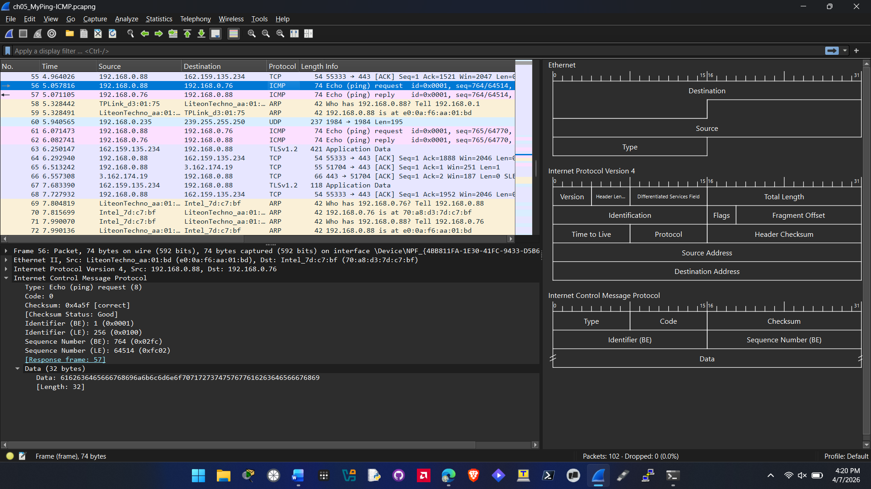
- Hands On Project 5-2
  - Screenshot showing the filter created for your own IP address
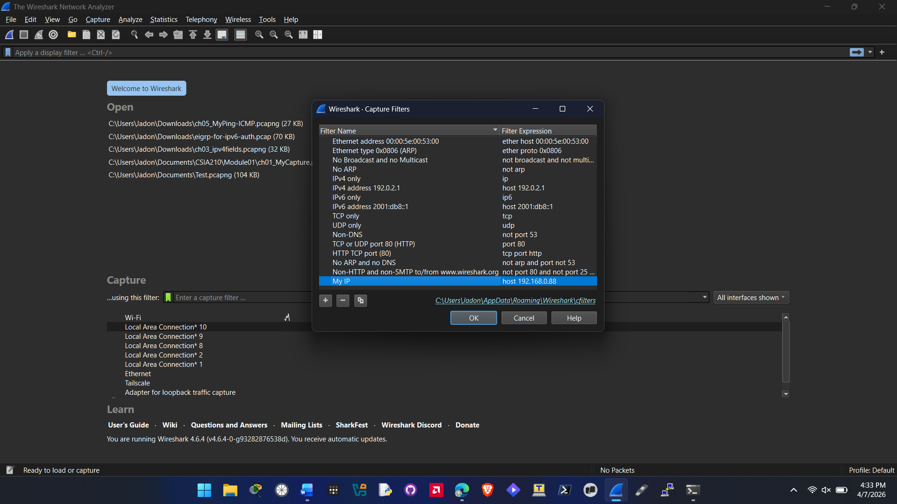
  - Screenshot showing the filter applied for only your IP address
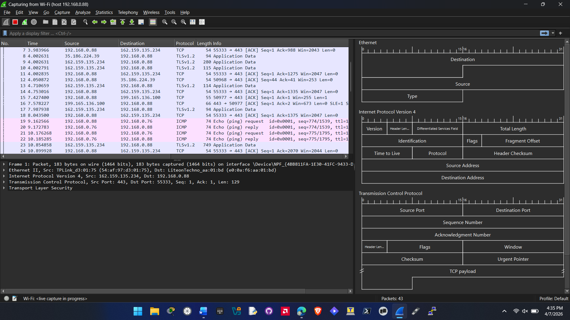
- Hands On Project 5-3 using trace file
  - Screenshot showing only filtered ICMP v4 and v6 packets
